Expose services in the cluster with node port, cluster IP, load balancer

Pods are ephemeral. And they are meant to be. They can be seamlessly destroyed and replaced if using a Deployment. Or they can be scaled at some point when using Horizontal Pod Autoscaling (HPA).

This means we can’t rely on the Pod IP address to connect with applications running in our containers internally or externally, as the Pod might not be there in the future.

You may have noticed that Kubernetes Pods get assigned an IP address:

stable-kube-state-metrics-758c964b95-6fnbl 1/1 Running 0 3d20h 100.96.2.5 ip-172-20-54-111.ec2.internal <**none**> <**none**>

stable-prometheus-node-exporter-4brgv 1/1 Running 0 3d20h 172.20.60.26 ip-172-20-60-26.ec2.internal

Code language: HTML, XML (xml)

This is a unique and internal IP for this particular Pod, but there’s no guarantee that this IP will exist in the future, due to the Pod’s nature.

**Services**

A **Kubernetes Service** is a mechanism to **expose applications both internally and externally**.

Every service will create an everlasting IP address that can be used as a connector.

Additionally, it will open a port that will be linked with a targetPort. Some services can create ports in every [Node](https://sysdig.com/learn-cloud-native/kubernetes-101/what-is-a-kubernetes-node/), and even external IPs to create connectors outside the cluster.

With the combination of both IP and Port, we can create a way to uniquely identify an application.

**Creating a service**

Every service has a selector that filters that will link it with a set of Pods in your cluster.

spec:

selector:

app.kubernetes.io/name: myapp

So all Pods with the label *myapp* will be linked to this service.

There are three port attributes involved in a Service configuration:

ports:

- port: 80

targetPort: 8080

nodePort: 30036

protocol: TCP

* port: the new service port that will be created to connect to the application.
* targetPort: application port that we want to target with the services requests.
* nodePort: this is a port in the range of 30000-32767 that will be open in each node. If left empty, Kubernetes selects a free one in that range.
* protocol: TCP is the default one, but you can use others like SCTP or UDP.

You can review services created with:

kubectl **get** services

kubectl **get** svcCode language: JavaScript (javascript)

**Types of services**

Kubernetes allows the creation of these types of services:

* ClusterIP (default)
* Nodeport
* LoadBalancer
* ExternalName

Let’s see each of them in detail.

**ClusterIP**

This is the default type for service in Kubernetes.

As indicated by its name, this is just an address that can be used inside the cluster.

Take, for example, the initial helm installation for Prometheus Stack. It installs Pods, Deployments, and Services for the Prometheus and Grafana ecosystem.

NAME TYPE CLUSTER-IP EXTERNAL-IP PORT(S) AGE

alertmanager-operated ClusterIP None <**none**> 9093/TCP,9094/TCP,9094/UDP 3m27s

kubernetes ClusterIP 100.64.0.1 <**none**> 443/TCP 18h

prometheus-operated ClusterIP None <**none**> 9090/TCP 3m27s

stable-grafana ClusterIP 100.66.46.251 <**none**> 80/TCP 3m29s

stable-kube-prometheus-sta-alertmanager ClusterIP 100.64.23.19 <**none**> 9093/TCP 3m29s

stable-kube-prometheus-sta-operator ClusterIP 100.69.14.239 <**none**> 443/TCP 3m29s

stable-kube-prometheus-sta-prometheus ClusterIP 100.70.168.92 <**none**> 9090/TCP 3m29s

stable-kube-state-metrics ClusterIP 100.70.80.72 <**none**> 8080/TCP 3m29s

stable-prometheus-node-exporter ClusterIP 100.68.71.253 <**none**> 9100/TCP 3m29sCode language: HTML, XML (xml)

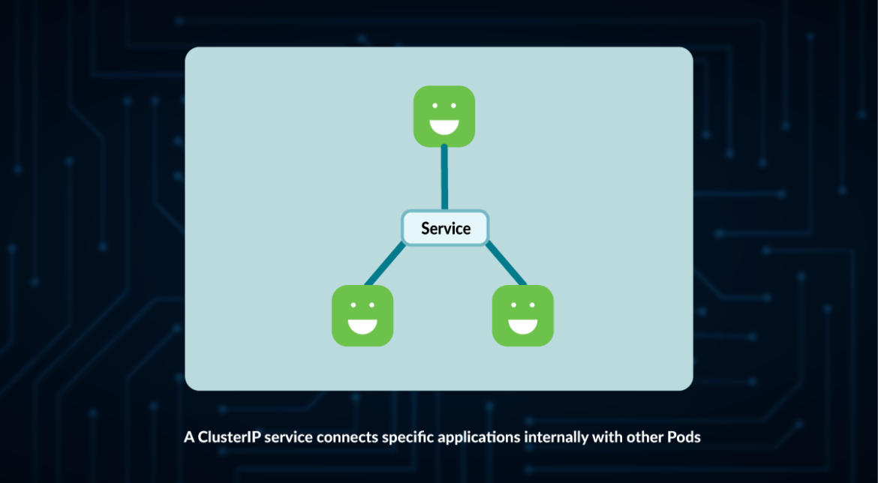

This creates a connection using an internal Cluster IP address and a Port.

But, what if we need to use this connector from outside the Cluster? This IP is internal and won’t work outside.

This is where the rest of the services come in…

**NodePort**

A NodePort differs from the ClusterIP in the sense that it exposes a port in each Node.

When a NodePort is created, kube-proxy exposes a port in the range 30000-32767:

apiVersion: v1

kind: Service

metadata:

name: myservice

spec:

selector:

app: myapp

type: NodePort

ports:

- port: 80

targetPort: 8080

nodePort: 30036

protocol: TCP

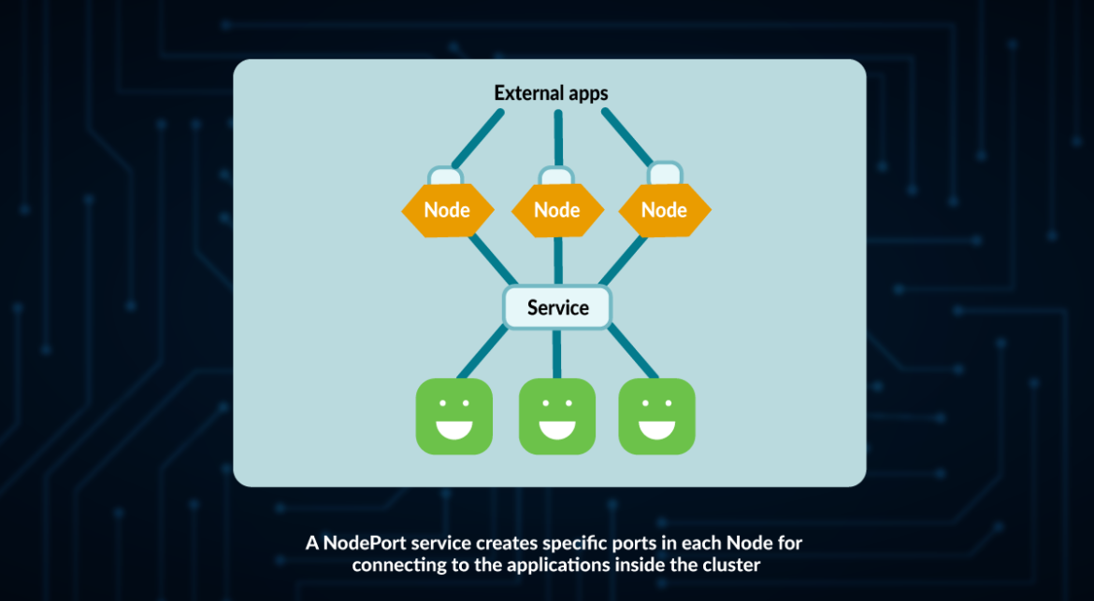

NodePort is the preferred element for non-HTTP communication.

The problem with using a NodePort is that you still need to access each of the Nodes separately.

So, let’s have a look at the next item on the list…

**LoadBalancer**

A LoadBalancer is a Kubernetes service that:

* Creates a service like ClusterIP
* Opens a port in every node like NodePort
* Uses a LoadBalancer implementation from your cloud provider (your cloud provider needs to support this for LoadBalancers to work).

apiVersion: v1

kind: Service

metadata:

name: myservice

spec:

ports:

- name: web

port: 80

selector:

app: web

type: LoadBalancer

my-service LoadBalancer 100.71.69.103 <**pending**> 80:32147/TCP 12s

my-service LoadBalancer 100.71.69.103 a16038a91350f45bebb49af853ab6bd3-2079646983.us-east-1.elb.amazonaws.com 80:32147/TCP 16m

Code language: HTML, XML (xml)

In this case, Amazon Web Service (AWS) was being used, so an external IP from AWS was created.

Then, if you use kubectl describe my-service, you will find that several new attributes were added:

Name: my-service

Namespace: default

Labels: <**none**>

Annotations: <**none**>

Selector: app.kubernetes.io/name=pegasus

Type: LoadBalancer

IP Family Policy: SingleStack

IP Families: IPv4

IP: 100.71.69.103

IPs: 100.71.69.103

LoadBalancer Ingress: a16038a91350f45bebb49af853ab6bd3-2079646983.us-east-1.elb.amazonaws.com

Port: <**unset**> 80/TCP

TargetPort: 9376/TCP

NodePort: <**unset**> 32147/TCP

Endpoints: <**none**>

Session Affinity: None

External Traffic Policy: Cluster

Code language: HTML, XML (xml)

The main difference with NodePort is that LoadBalancer can be accessed and will try to equally assign requests to Nodes.

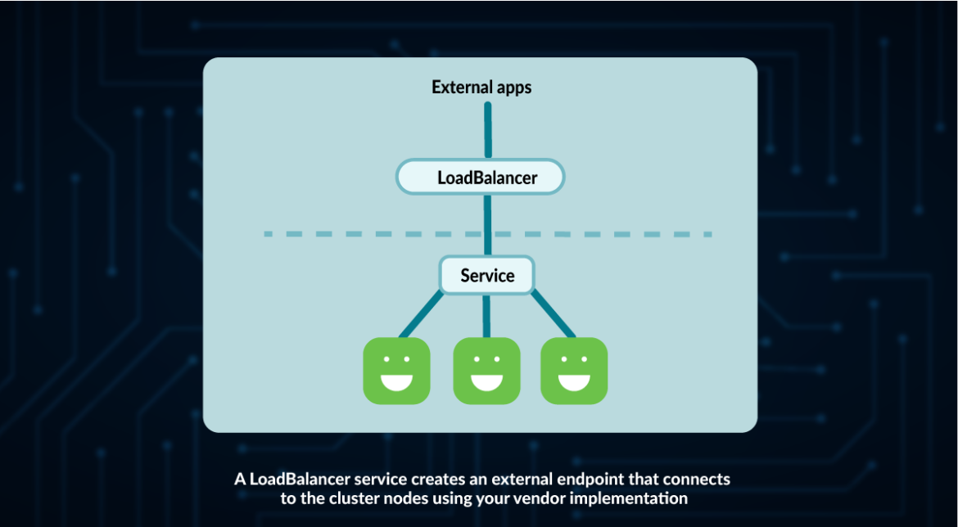

**ExternalName**

The ExternalName service was introduced due to the need of connecting to an element outside of the Kubernetes cluster. Think of it not as a way to connect to an item within your cluster, but as a connector to an external element of the cluster.

This serves two purposes:

* It creates a single endpoint for all communications to that element.
* In case that external service needs to be replaced, it’s easier to switch by just modifying the ExternalName, instead of all connections.

**apiVersion**: **v1**

**kind**: **Service**

**metadata**:

**name**: **myservice**

**spec**:

**ports**:

**-** **name**: **web**

**port**: 80

**selector**:

**app**: **web**

**type**: **ExternalName**

**externalName**: **db**.myexternalserver.com

Code language: CSS (css)